**QWC Community autonomy and development**

—by canghai

### QWC Community Spirit

*Devote to earn community respect. Unity brings us to the path of glory.*

### Overall Framework

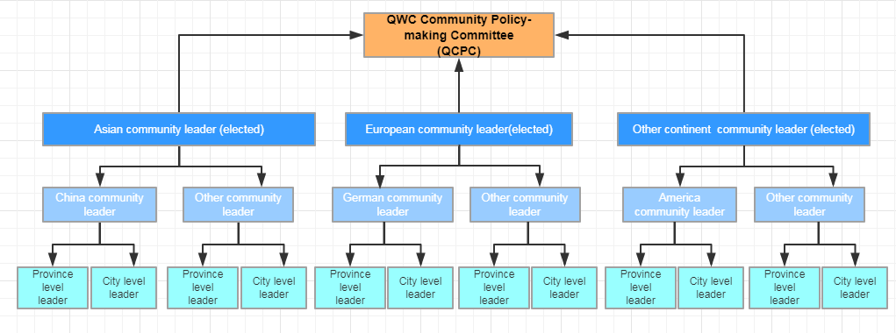

1. Based upon scale and activeness, current QWC communities can be divided into Asian community, European community, and Other continent community. We will elect one leader for each community. And these 3 leaders are so-called **Community Leader**, who will form the **QWC Community Policy-making Committee (QCPC).**
2. **Community Leader** are responsible for the overall QWC planning and promotion work from his own region, and he should regularly report his progress to the whole QWC community.
3. Each **Community Leader** can recommend several QWC Country leaders, who are responsible for QWC promotion and marketing work inside their own countries. **Country Leader** will report to both Community Leader and the QWC community of his own country.
4. Each **Country Leader** can recommend several QWC province leaders, who are responsible for QWC promotion and marketing work inside their own province. **Province Leader** will report to both corresponding Country leader and Community Leader.

### Funding Guarantee

1. The **QWC Community Policy-making Committee (QCPC)** will be responsible for the fund management of the whole QWC community.
2. Based upon community activeness, the Asian community, European community, and Other community will each get 200 million QWC as an initial fund, which will be used to exchange listing and promotion/marketing usage.
3. Each **Country Leader** will be responsible for the fund usage of his region. And will regularly report to both Community Leader and the QWC community of his own country.
4. Every **Community Leader** can initiate QWC donation among his own community, and has the rights to manage and decide the usage of donated QWC.

### Term of Validity

The above terms apply for one year.

2019-07-29